LAB221 Assignment | Type: | Short Assignment
 | Code: | J2.S.P0111
 | LOC: | 150
 | Slot(s): | 2

Title
Create calculator
Background Context
NA

Program Specifications
- Use swing library to create a program to simulate calculator with basic functions: add, subtract, divide, multiple, square.

Function details:

NA
Expectation of User interface:
The screen should be as:

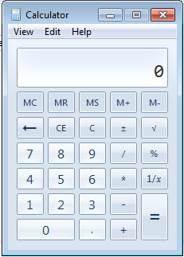

Guidelines

